Burndown Chart:

This Chart represents the amount of work remaining to perform vs the time available. It can be done in any project in which progress over time matters.

Elements In Burndown Chart:

Horizontal Axis -> represent the time.

Vertical Axis -> represent the amount of work.

The project starts from upper left to lower right.

Blue line -> total work planned.

Orange line -> Pending work.

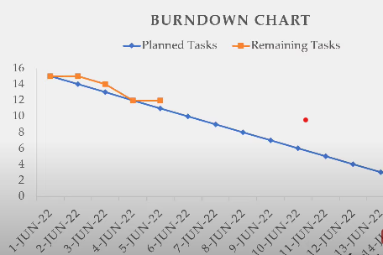

Why we use burndown Chart?

Keep tracking the amount of work remaining in the sprint.

Maintaining the team’s schedule.

Comparing the scheduled work with progress of the work.

Track the project’s scope.

Burndown Chart Example:

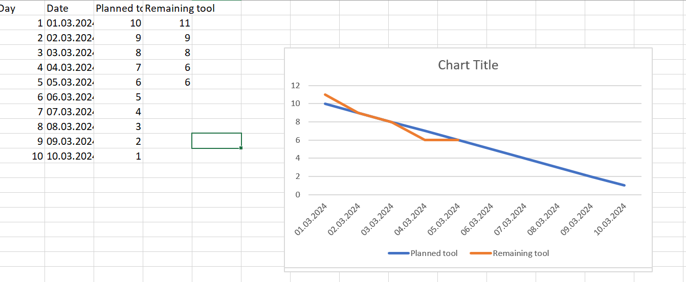

Why use Excel for burndown chart?

Time – consuming.

No mobile device needed.

Non – collaborative